
VILNIUS UNIVERSITY
ŠIAULIAI ACADEMY
BACHELOR PROGRAMME SOFTWARE ENGINEERING

Object-Oriented Programming assignment no 3

Student: Muhammad Abdul Rehman
Lecturer: Donatas Dervinis

Šiauliai, 2025

Tasks:
- Create a child class (inheritance) based on the class of the previous task (3x+1) by adding new method wich can calculate statistics (histogram ) of function 3x+1 iteration values ​​from interval [n;m]
- Set correct variable modifiers (public, private...);
- Use 2-3 constant values.)

Code:
<?php
// Parent class for Collatz Conjecture
class Collatz {
// constants
const EVEN_DIVISOR = 2;
const ODD_MULTIPLIER = 3;
const ADD_ONE = 1;
// protected variable
protected $number;
// constructor
public function __construct($number) {
$this->number = $number;
}
// method to generate Collatz sequence
public function generateSequence() {

$x = $this->number;
$sequence = [];
while($x != 1) {
$sequence[] = $x;
if($x % self::EVEN_DIVISOR == 0) {
$x = $x / self::EVEN_DIVISOR;
}
else {
$x = self::ODD_MULTIPLIER * $x + self::ADD_ONE;
}
}
$sequence[] = 1;
return $sequence;
}
}
// Child class (Inheritance)
class CollatzHistogram extends Collatz {
// private variable
private $histogram = [];
// method to calculate histogram for interval [n;m]
public function calculateHistogram($n, $m) {
for($i = $n; $i <= $m; $i++) {
$this->number = $i;
$sequence = $this->generateSequence();
$length = count($sequence);
if(!isset($this->histogram[$length])) {
$this->histogram[$length] = 0;
}
$this->histogram[$length]++;
}
return $this->histogram;
}
// display histogram
public function showHistogram($n,$m) {
$hist = $this->calculateHistogram($n,$m);
echo "<h3>Histogram of Collatz sequence lengths</h3>";
foreach($hist as $length => $count) {
echo "Sequence length $length : $count numbers <br>";
}
}
}
// HTML form (similar to your previous assignment)
echo "<h2>Collatz Conjecture Histogram</h2>";
echo '<form method="post">
Start number (n): <input type="number" name="n" required><br><br>
End number (m): <input type="number" name="m" required><br><br>
<input type="submit" value="Calculate Histogram">
</form>';
// process input
if(isset($_POST['n']) && isset($_POST['m'])) {
$n = $_POST['n'];
$m = $_POST['m'];
$obj = new CollatzHistogram($n);
$obj->showHistogram($n,$m);
}
?>

UML Diagram:
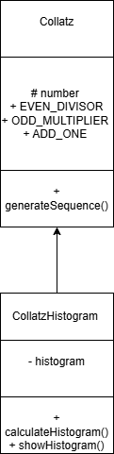

Output:
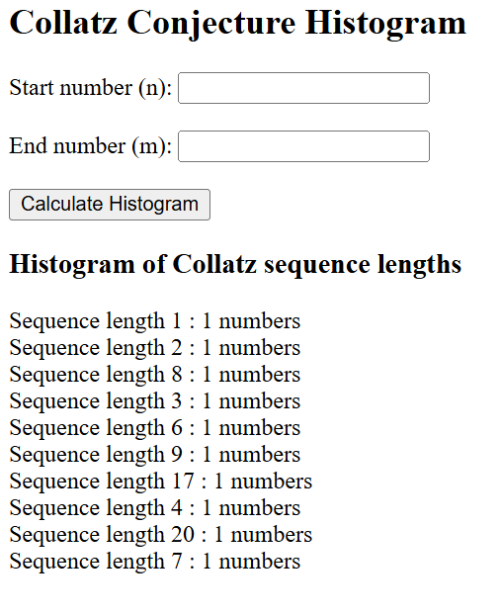
Figure 1: Input 1(n) and 10(m) and it gives output

Explanation:
This program is an improved version of the previous Collatz assignment. In the previous work, the sequence was calculated using simple loops. In this assignment, Object-Oriented Programming is used to organize the code.A parent class named Collatz is created to generate the sequence using the rules of the 3x+1 function. It uses constants and a protected variable to store the number.A child class CollatzHistogram extends the parent class and adds a new method to calculate statistics for numbers in the interval [n;m]. It counts how many steps are required for each number to reach 1 and stores the results in a histogram.This approach improves code reusability and makes the program more structured.

